# **Tasks**

**Learners have to develop a dashboard to support the answers to the following questions.**

**Objective Questions**:

1. What is the total no. of tables present in the data?

Ans. The dataset contains only a single table for analysis.

1. What is the total no. of attributes present in the data?

Ans. The datasheet comprises a total of 35 attributes that require thorough cleansing and detailed analysis.

1. The data consists of some inconsistent and missing values so ensure that the data used for further analysis is cleaned.

* **Ans. Hidden Irrelevant Columns: Some columns were irrelevant according to the description given in the slides. These are as follows:**
* time-duration: They are marked irrelevant according to the description given.
* isWhiteListUser and queue: Both these columns have single values in each row. So, they do not require calculation.
* Data Cleaning and Extraction: Cleaned and extracted from the following columns:
* createdAt
* updatedAt

* chatStartTime

* chatEndTime

1. What is the average daily call volume over the day by day and what’s the change on it?

**Answer.** Average call per day = 250

The pivot table in the *‘Calculations and Pivots’* sheet highlights the **daily call volume**, showing how calls are grouped by day and the total count for each.

### **Key Insights:**

* There’s a noticeable decline in daily call volume over time.
* If this trend continues, it could hurt revenue, so it’s crucial for stakeholders to take action.

### **Suggestions:**

* The drop in call volume might be due to fewer new users signing up or lower retention of existing users—though more analysis is needed to confirm this.
* To address this, stakeholders could:
  + **Boost marketing efforts** to attract more users.
  + **Focus on improving services** to retain existing users and keep them engaged.

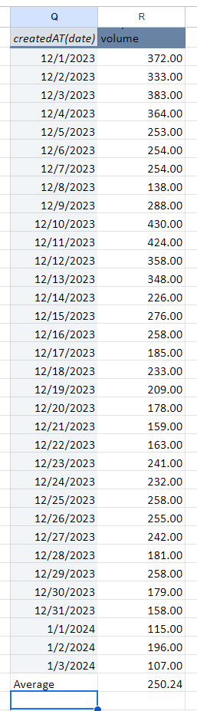

1. Which months experienced the highest and lowest call volumes?

Ans. Since the data covers only one month (December 2023) and a few days in January 2024, one cannot calculate long-term trends based on this shortest time interval.  
  
Still, we can see the following:

* The **highest call volume** was recorded on **10th December 2023**, with **430 calls**.
* The **lowest call volume** was observed on **3rd January 2024**, with just **107 calls**.

.

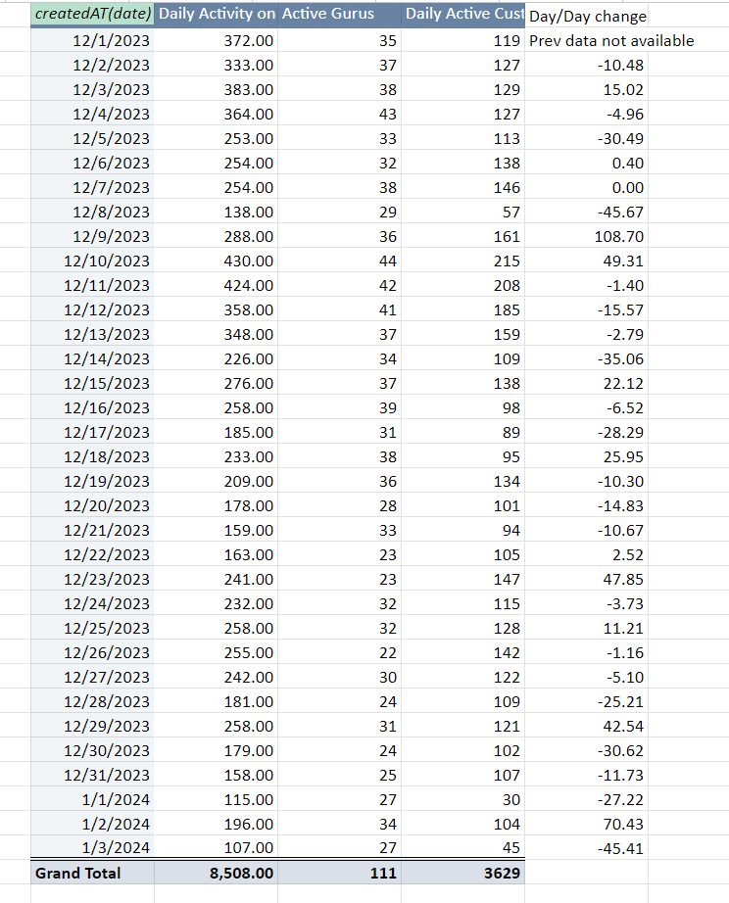

1. What is the total operational cost for that month?

Ans. The approach involves considering the astrologers' earnings as part of the operational costs and calculating the total over the months.

### **Formula Used:**

=SUMIFS

This formula allows summing values based on specific conditions, such as filtering by month or other relevant criteria.

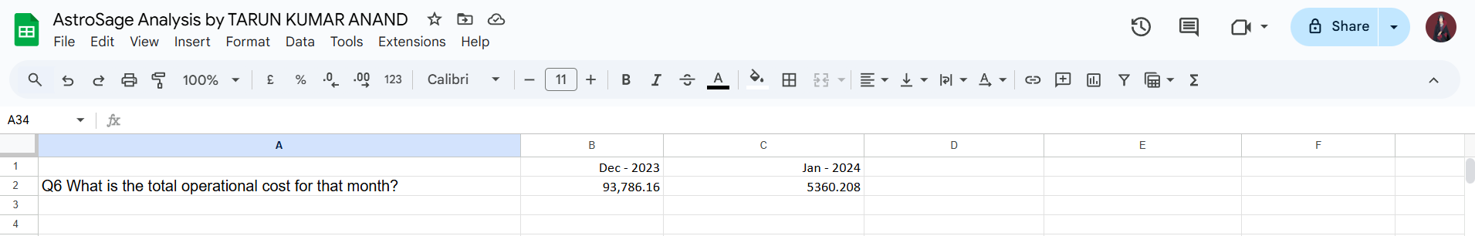

1. What is the average number of calls handled per agent per day?

The **average number of calls handled per agent per day** is **1.91**. This was calculated by dividing the total number of calls by the product of the number of days and the number of agents.

### **What This Suggests:**

* With only 1.91 calls per agent per day, this is quite low, indicating:
  + Possibly fewer users engaging with the service, or
  + A drop in overall traffic.
* When you consider this alongside the declining daily call volumes, it suggests there might be a deeper issue with the business. If this trend continues, it could lead to major problems, potentially affecting revenue and growth.

### **What Needs Attention:**

This low engagement could be a sign of underlying issues such as poor user acquisition or retention. Immediate action is needed to understand the root cause and address it before the situation worsens.

.

1. How many repeat callers are there, and what percentage of total calls do they represent?

Ans. There are a total of 1277 repeat callers. Calculation for the same is present in the second sheet of the spreadsheet file.

Steps taken to calculate this :

* Grouped the data of userId in a pivot table and added userId(count) to get the number of calls made by each user. calculated the total no of callers.
* Applied count function over the first column to count the total number of callers.
* Applied count function to count the users with a single call.
* Subtracted Total One time callers from Total number of callers to get repeat callers.

In order to obtain the percentage of total calls that repeat callers represent,

Formula used is:

(Total number of Call - Total number of Callers)x100/total number of calls



1. What is the total sales generated by the call center for each product category?

* **Green bars** indicate the number of activities (or interactions) received by different products or consultation types.
* **Blue bars** represent the revenue generated from these activities.

The data shown in the chart is sourced from the pivot table below, which has been copied from the *Dashboard* sheet of the spreadsheet file.

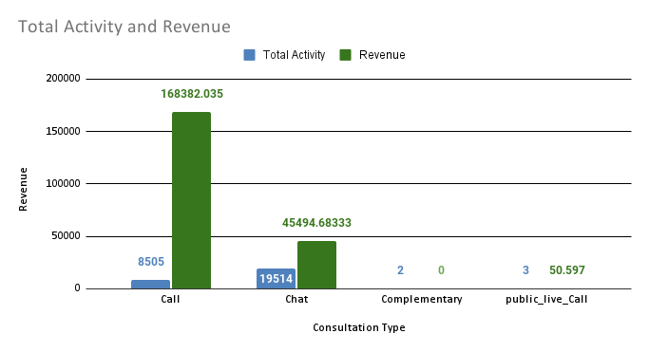

1. How many calls were made for each user ID and guru ID?

These two pivot tables provide detailed data on:

* The **number of calls made by each user**.
* The **number of calls received by each agent/guru**.

**Answer:**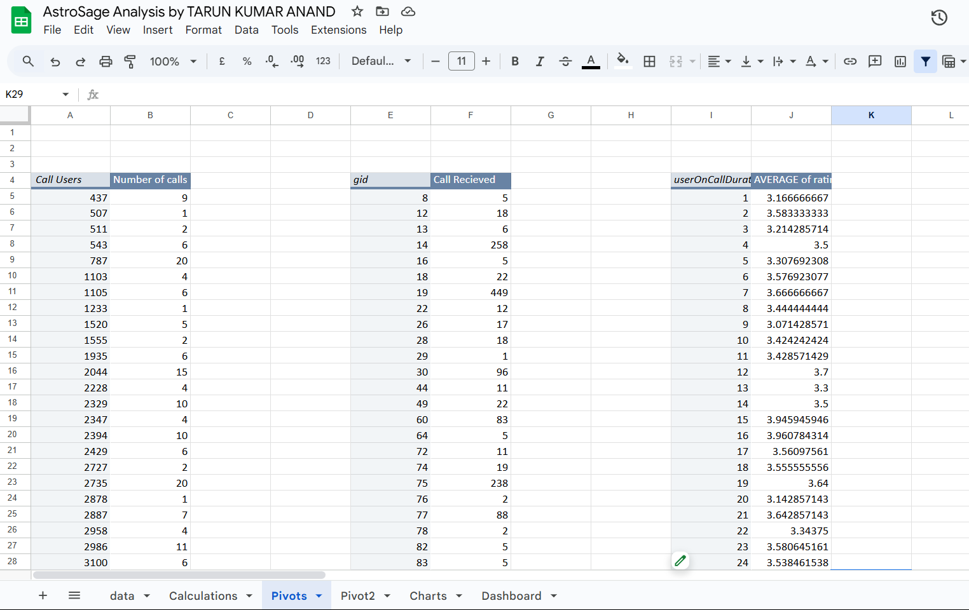

1. What is the correlation between call duration and customer satisfaction?

Answer. As a proper column for customer satisfaction was not available therefore considered rating as a metric to assess customer satisfaction and used that for calculation.

Formula used : CORREL(Range of UserOnCallDuration, Range of Ratings)

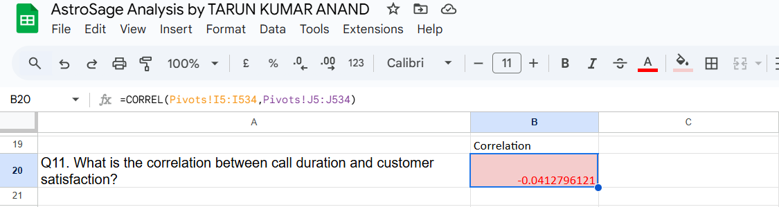

A correlation of -0.041 suggests a very weak negative correlation between the two variables being analyzed. This means:

* **Direction:** As one variable increases, the other variable tends to decrease very slightly. However, this relationship is so weak that it's almost negligible.
* **Strength:** The correlation is very close to 0, which indicates that the two variables are essentially independent of each other. Any observed trend is likely due to random chance rather than a meaningful relationship.

In practical terms, this correlation coefficient implies that knowing the value of one variable provides very little information about the likely value of the other variable.

**Key takeaway:** The two variables are almost unrelated.

1. Which guru have the highest and lowest customer satisfaction scores?

* Ans The **guru with the highest average rating** is **Tarot Mystical**.
* The **guru with the lowest average rating** is **Tarot Rittika**.

1. What is the average customer satisfaction score by month?

Answer:

The average ratings for the two months are as follows:

* **December 2023**: 2.9496
* **January 2024**: 2.6764

### **Formula Used:**

For **December 2023**:

=AVERAGEIFS(data!AN:AN, data!Q:Q, ">=12/01/2023", data!Q:Q, "<=12/31/2023")

For **January 2024**:

=AVERAGEIFS(data!AN:AN, data!Q:Q, ">=01/01/2024", data!Q:Q, "<=01/31/2024")

These formulas calculate the average rating based on the data within the specified date ranges.

1. How many categorical columns are there in the data? [Search about categorical and continuous data, and try to answer this question]

Ans. 15

chatStatus, consultationType, website, refundStatus, isWhiteListUser, queue, freeCall, freeChat, callChannel, callIvrType, callStatus, astrologerCallStatus, region, userCallStatus, rating

**Subjective Question:**

1. Should the investment be used to hire more agents, improve training programs, or upgrade call center technology?

Answer.

Approach used:

* Analysis of daily active users trend via. Line chart

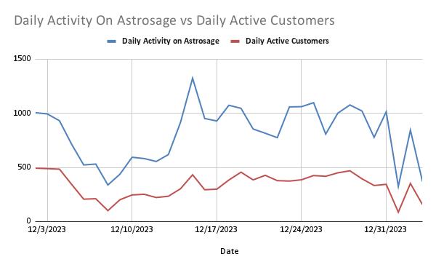

* Analysis of volume/work distribution via pivot table
* Analysis of average rating per guru via pivot table

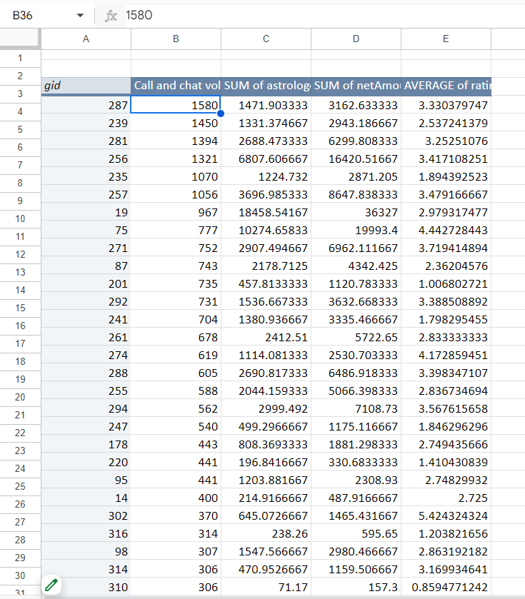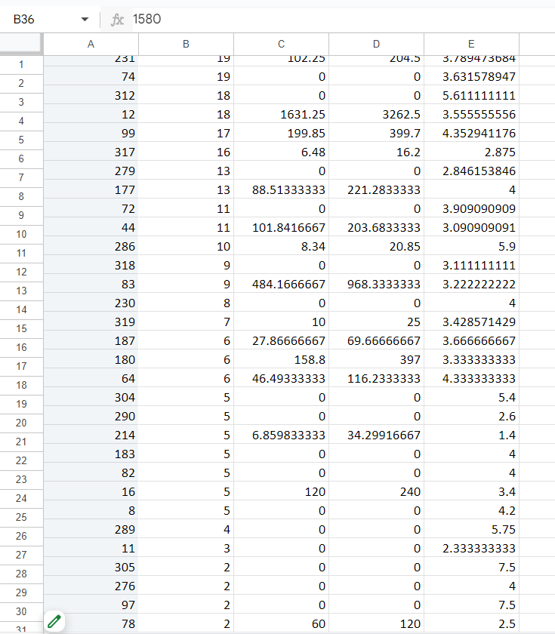

* Average rating distribution to gurus analysis via column chart.

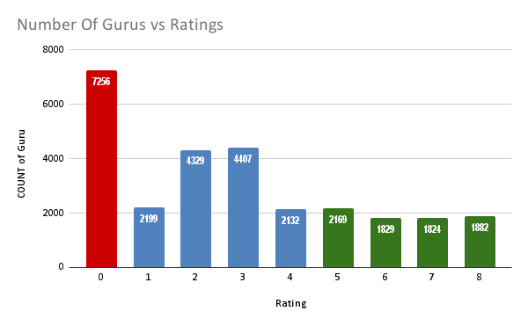

After analyzing the data provided, below are the findings:

Findings:

1. Daily active users decreasing on both app and website
2. activity on chat is 70% of total v/s 30% on call. Yet the revenue generated over call is Rs168442 v/s Rs45495 over chat.
3. Out of 8508 total calls 3450 calls are completed(callStatus = “completed”)(40.5% completion)
4. Out of 8508 total calls 1270 calls are marked busy(callStatus = “busy”, astrologerStatus = “busy” and “completed”, userCallStatus = “busy” and blank)(14.9% busy)
5. Rating Distribution: A significant portion of sessions received a rating of 0, indicating dissatisfaction or unresolved sessions. The highest counts are for ratings 0 (7256 sessions), 3 (4407 sessions), and 2 (4329 sessions) obtained from applying filter over the ratings column.



This is a chart from the dashboard that shows the distribution of average rating received by the Gurus/agents. It depicts that a major portion lies below the 3.64 mark out of 8(maximum possible rating) suggesting that the user’s experience is not up to the mark.



This is the pivot table present below to the dashboard.

The second column corresponds to the number of queries(both call/chat request) received by the agents. The volume distribution among the gurus is not uniform and some of the gurus are overutilized while some are severely underutilized.

***Suggestion*:** A portion of the investment received should be used for the following:

* Technology of the Call Center should be optimized to distribute the volume in a uniform manner such that there is proper utilization of the workforce.
* Focus on improving customer interactions by providing targeted training for agents and possibly enhancing call center technology to resolve issues that lead to poor customer experiences.

1. What are the potential risks of each investment option (hiring, training, technology upgrades), and how can they be mitigated?

Name the chart/spreadsheet function you will use for solving the problem?

Answer:

* Technological Upgrades-Risks
* Installation Problems:
* New technology might introduce a learning curve and a few unexpected technical anomalies that could stall or complicate implementation. The transition phase might also cause operational interruptions if not well handled.
* High Implementation Costs:
* It is a technology improvement investment that is generally heavy-duty and not very tangible in terms of its results immediately. Thus, it can exert some pressure on the cash flow and put a strain on short-term financial objectives.
* Mitigation Strategies:
* Phased Rollout:
* Rather than releasing upgrades, rolling them out progressively is much smoother. This helps focus on technical issues early and minimizes disruptions to operations. It also affords the opportunity to commence with a small-scale pilot group before the need for expansion arises following the results.
* Cost-Benefit Analysis
* Invest in a full cost-benefit analysis so that the investment aligns with improvements in operational efficiency and profitability expectations. This helps justify early investment costs, measuring whether long-term benefits outweigh the risks.
* Possible Risks In Training Agents
* High Costs:
* Training programs do not come cheap. They take not only direct costs but also the opportunity cost of time away from customer-facing activities. For bigger teams, the cost really adds up.
* Retention Issues:
* There is also a chance that training for agents leaves them leaving the company for better opportunities. This means one loses not only the investment into their development but also the time that has elapsed during training.
* Mitigation Strategies:
* Measure Training Effectiveness:
* Track agent performance pre-and post-training for training effectiveness measurement. This allows profiling areas of improvement and ensures the training program can deliver measurable results. Programmes can be continually honed into effectiveness based on these insights.
* Retention Programs
* Retention Incentive in the form of performance-based bonuses or career development opportunities. This will keep trained agents motivated and reduce the tendency to leave for other opportunities.

Functions to Help Improve:

Function: WHATIF Analysis or Goal Seek

Apply:

These functions enable you to determine how changes to key variables (such as the number of agents you are hiring or the cost of technology purchases) will affect outcomes. Goal Seek is especially useful in identifying when an investment will breakeven, providing crucial information to inform decision-making.

Graphics Tools:

Function: Charts (such as Bar Charts, Pie Charts, Waterfall Charts)

Apply:

Charts are powerful ways of visualizing information to make complex information easier to digest. For example, waterfall charts show well how every investment decision impacts the overall financial picture over time, and bar and pie charts help to visualize the distribution of risks, costs, and returns. These visualizations can assist stakeholders in quickly understanding key trends and making well-informed decisions.

**Q3.**How does AstroSage call center performance compare to that of AstroGuru in terms of average call volume, customer satisfaction, and agent performance?

Will you use any aggregation function or a visualization here to solve the problem?

**Answer**. Data for AstroGuru is not provided for the analysis.

**Q4.**How can the call center improve its handling of peak call periods to ensure high customer satisfaction?

Mention the functionality which you will use for giving the suggestions, will it be any aggregate function or a visualization?

**Answer.**

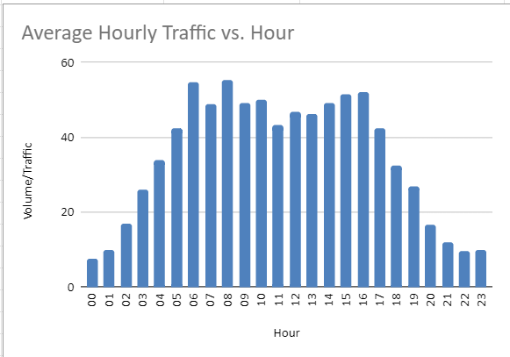

The given chart depicts the data of Average hourly traffic on the Y-axis and the hour of the day on the X-Axis.

Inference from the data:

* Daily traffic peaks at 6am and remains in the same range till 4pm(16:00) after which it starts to drop. Therefore, the range of 6am to 4pm is pretty important for the business and must be handled by highly skilled professionals in order to achieve high customer satisfaction.

Suggestions:

Flexible Staffing: Use part-time, on-demand, or freelance agents who can be called in during peak times. Having a reserve pool of trained agents will help balance the workload without increasing permanent staffing costs.

Shift Optimization: Optimize agent shifts to peak periods accordingly. Ensure that more agents are scheduled during the high-traffic times.

Process of analysis:

* Extracting the hours from the date of creation by utilizing Right and Left functions.

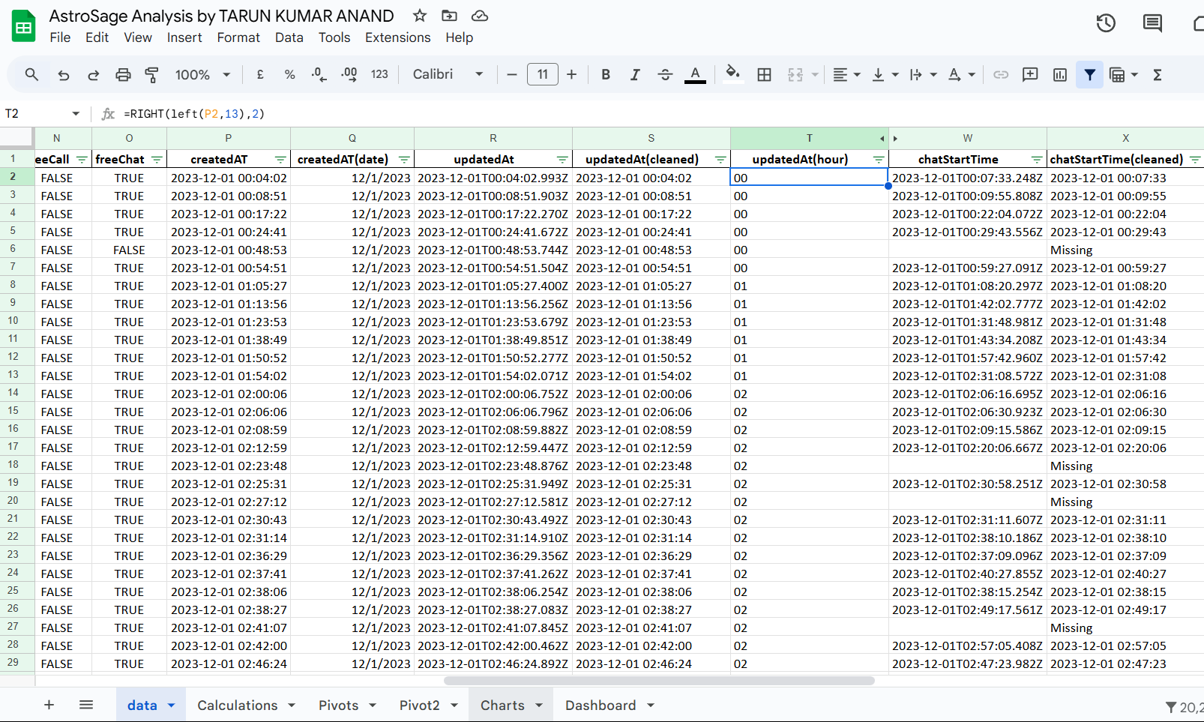

* Creating a pivot table to summarize the data of hourly volume v/s day.
* Calculating the average of hourly traffic/volume.

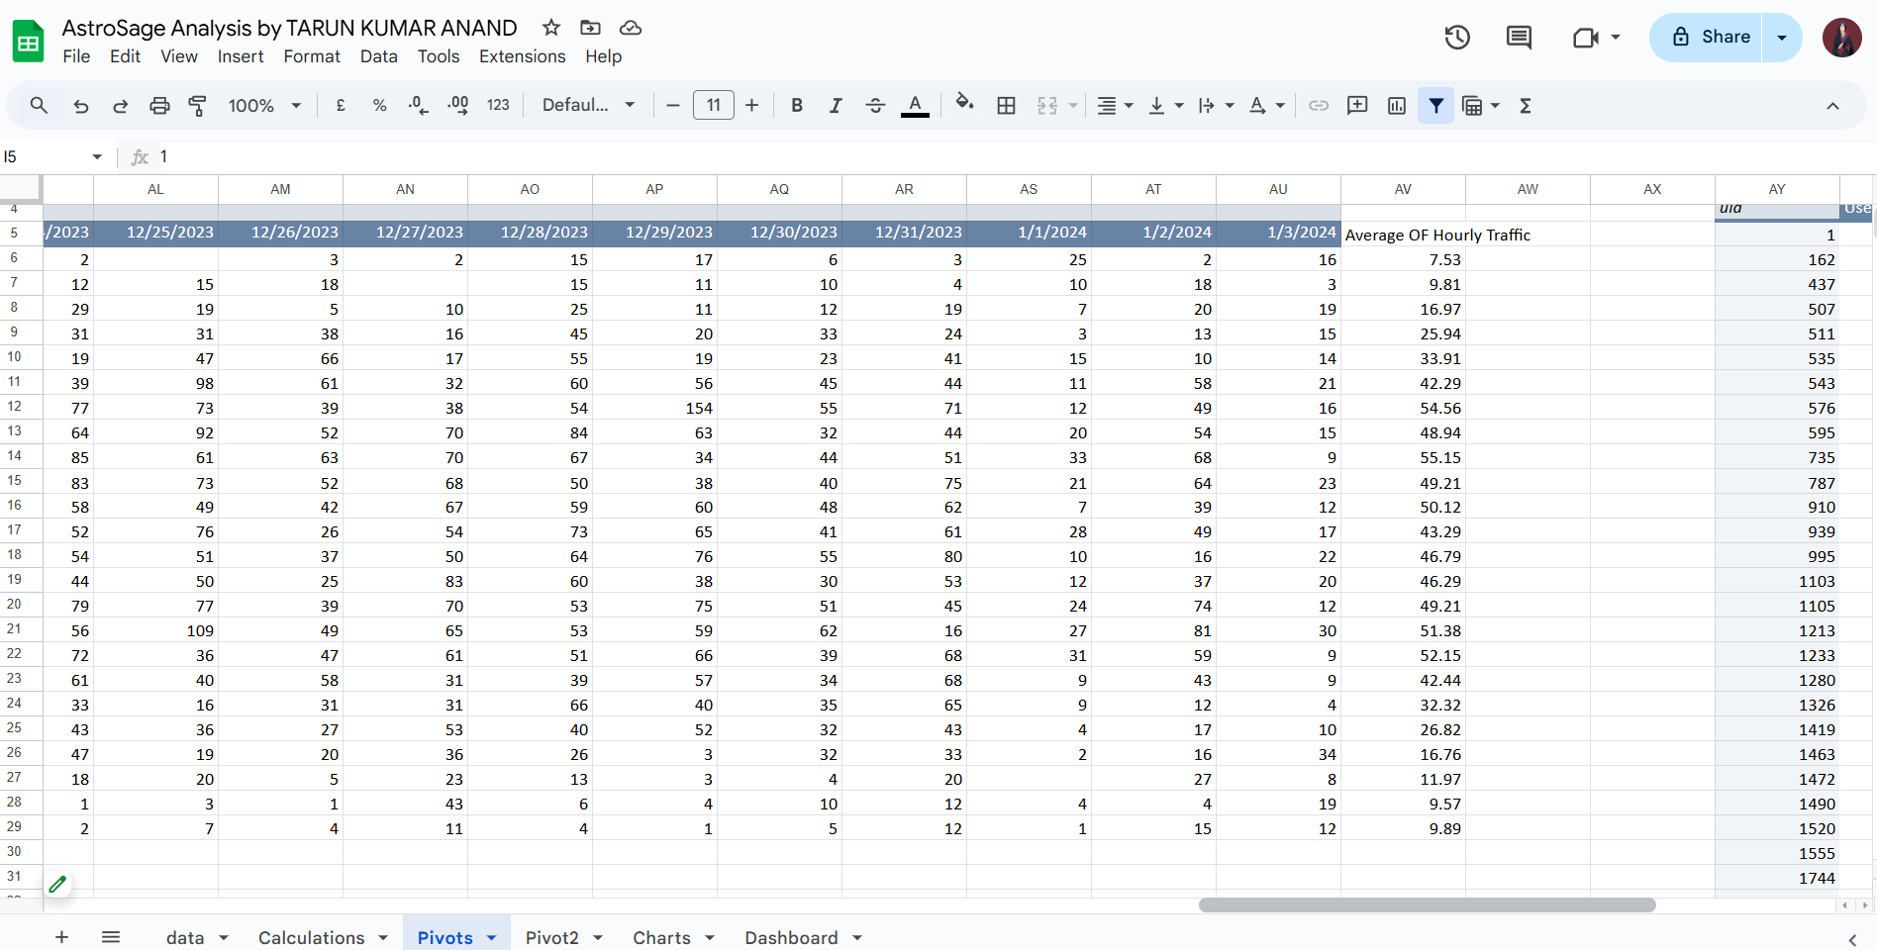

* Creating a column chart to visualize the hourly traffic.

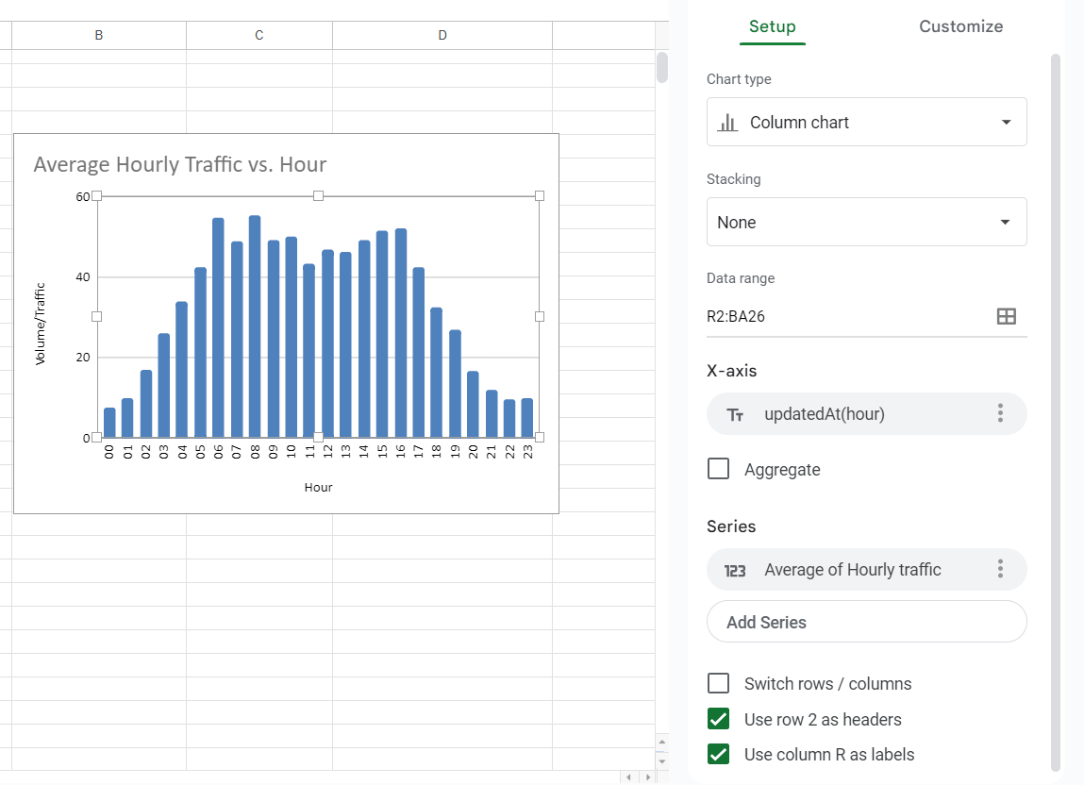

**Q5**.Based on historical data, what strategic initiatives should be prioritized to improve overall efficiency and customer satisfaction?

**Answer**:

### **Strategic Initiative 1: Targeted Training for Underperforming Agents**

Historical call center data reveals that certain agents exhibit high failure rates and receive low customer ratings. Addressing their performance through targeted training can significantly improve efficiency and customer satisfaction.

#### **Action Plan:**

1. **Identify Underperforming Agents:**
   1. Use data to pinpoint agents with consistently low ratings and high call failure rates.
2. **Develop Customized Training Programs:**
   1. Tailor training sessions to address specific areas for improvement, such as:
      1. **Communication Skills**: Enhancing clarity and tone in conversations.
      2. **Problem-Solving Skills**: Teaching effective techniques for resolving customer issues.
      3. **Technical Knowledge**: Strengthening product and service expertise.
3. **Implement Training Sessions:**
   1. Conduct focused and interactive workshops to address identified gaps.
4. **Assess Post-Training Performance:**
   1. Regularly evaluate agents’ performance after training to measure improvement.
   2. Use metrics such as reduced failure rates, improved customer ratings, and feedback to determine the effectiveness of the training.

#### **Expected Outcome:**

Enhanced agent performance will lead to better customer interactions, increased satisfaction, and improved operational efficiency.



The given chart illustrates the distribution of ratings across agents.

### **Key Observation:**

* A significant portion of the ratings is concentrated on the **left side** of the chart.
* This indicates that **customer satisfaction levels are predominantly low**, as reflected by the majority of lower ratings.

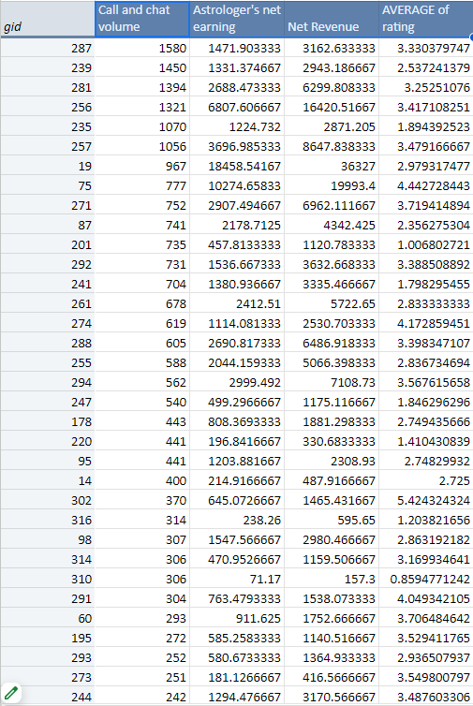

The **rating distribution**, as shown in the pivot table, provides valuable insights into agent performance. This data can be used to identify outliers or underperforming agents who may need additional support or intervention.

### **Suggested Actions:**

* **Targeted Training**:  
  Focus on agents with consistently low ratings to address specific performance gaps.
* **Specialized Support**:  
  Provide tailored coaching sessions to improve skills in areas such as communication, problem-solving, or product knowledge.

By leveraging this analysis, appropriate actions can be taken to enhance overall efficiency and boost customer satisfaction

.

### **Strategic Initiative 2: Enhanced Call Management and Priority Handling**

Efficient call routing is crucial for improving customer satisfaction and maximizing agent productivity. Poor routing leads to longer wait times, customer frustration, and inefficient agent utilization. Implementing smarter call management strategies can address these issues.

#### **Action Plan:**

1. **Implement Skill-Based Routing:**
   1. Utilize intelligent call routing systems to match customers with the agents best suited to handle their needs based on skills, expertise, and past performance.
2. **Introduce Priority Queuing:**
   1. Give precedence to valued or returning customers by prioritizing their calls, especially during peak times.
   2. Use customer segmentation to identify high-priority callers and ensure they are routed promptly.
3. **Dynamic Routing Rules:**
   1. Analyze performance reports to understand patterns in customer needs and agent capabilities.
   2. Regularly update routing rules to reflect changes in service demands or agent performance improvements.

#### **Expected Outcome:**

* **Faster Resolutions**: Customers are connected to the right agents quickly, reducing wait times.
* **Improved Satisfaction**: Priority handling ensures key customers feel valued, boosting loyalty.
* **Enhanced Efficiency**: Better agent-customer matches lead to more effective call handling and improved agent morale.

.

### **Strategic Initiative 3: Minimizing Call Failure Risks Through Technological Enhancements**

Call failures and technical challenges can significantly impact customer experience and satisfaction. Upgrading technology in call centers is essential to improve call quality, reduce failures, and enhance overall operational efficiency.

#### **Action Plan:**

1. **Invest in Reliable Infrastructure:**
   1. Upgrade communication systems to ensure better reliability, larger capacity, and fewer technical disruptions.
   2. Consider modern telephony solutions, such as cloud-based systems, for enhanced scalability and efficiency.
2. **Enhance IVR Systems:**
   1. Implement or improve Interactive Voice Response (IVR) systems to handle simple queries without needing an agent.
   2. Ensure the IVR system is user-friendly, with clear and efficient navigation paths to reduce customer frustration.
3. **Deploy Monitoring and Diagnostic Tools:**
   1. Use advanced tools to monitor call center operations in real time.
   2. Quickly diagnose and resolve technical issues as they arise, preventing disruptions.

#### **Expected Outcome:**

* Improved call quality and reduced failure rates.
* Increased efficiency by freeing up agents to focus on complex issues.
* Enhanced customer satisfaction through more reliable and seamless communication.

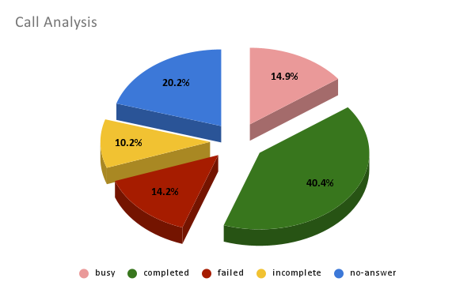

The Given Chart shows the failure rate of calls.

### **Strategic Initiative 4: Improving Self-Service Options**

Self-service options allow customers to independently resolve common issues, reducing the load on agents and improving efficiency during peak hours. By enhancing these options, businesses can save time for both customers and agents while increasing overall satisfaction.

#### **Action Plan:**

1. **Enhance IVR Systems:**
   1. Upgrade IVR to handle a wider range of frequently asked questions and guide users effectively without agent intervention.
   2. Include options for troubleshooting and account management to empower customers.
2. **Deploy AI-Powered Chatbots:**
   1. Introduce intelligent chatbots to address simple customer queries and offer quick solutions.
   2. Utilize machine learning to improve chatbot accuracy and personalize responses based on customer data.
3. **Promote Self-Service Channels:**
   1. Educate customers on how to use self-service options, including online portals, apps, and automated systems.
   2. Design interfaces that are intuitive and visually appealing, ensuring ease of use.
4. **Monitor and Optimize:**
   1. Regularly evaluate the performance of self-service tools based on customer feedback and usage data.
   2. Continuously update systems to address new customer needs or frequently asked questions.

### **Conclusion:**

Enhancing self-service tools, alongside targeted training, technological improvements, and better call routing, will lead to streamlined operations and improved customer satisfaction. This balanced approach ensures that resources are used effectively while empowering customers to solve issues independently.

**Q6.**What can be the key factors contributing to high customer satisfaction scores, and how can these be leveraged to improve overall performance?

What is the basis for the suggestions? And mention how did you decide if the satisfaction score affect the ratings?

### **Answer**: **Key Factors Contributing to High Customer Satisfaction Scores**

1. **Interaction with Agents:**
   1. High customer satisfaction is often driven by agents who are in demand and possess a higher level of expertise. These agents are better equipped to handle queries effectively, leading to positive experiences.
2. **Low Call Volumes per Agent:**
   1. Customer experience improves when agents have manageable workloads. With fewer customers to assist, agents can provide more personalized attention and higher-quality consultations.
   2. Overburdened agents may struggle to maintain efficiency, leading to a decline in satisfaction scores.

### **Performance Improvement Strategies**

* **Well-Trained Agents:**

Ensure agents are thoroughly trained and possess the necessary knowledge and skills to handle a variety of customer scenarios with confidence.

* **Manageable Workloads:**

Implement strategies to keep call volumes per agent at a manageable level to avoid burnout and maintain quality interactions.

* **Effective Scheduling:**

Use data-driven workforce management techniques to optimize agent availability during peak and off-peak times, ensuring better distribution of workload.

* **Continuous Learning:**

Encourage ongoing training and development programs to enhance agent expertise and adaptability.

By focusing on these strategies, the organization can consistently deliver better outcomes for customers and maintain high satisfaction levels.

.

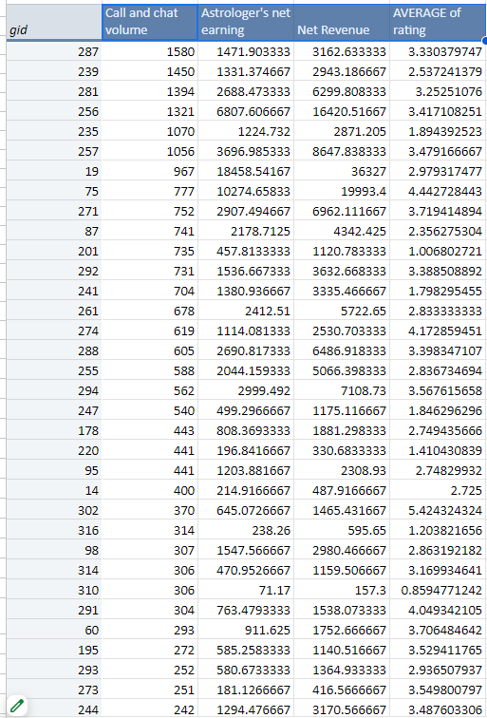

The pivot table brings out the efficiency of agents in handling customer calls.

Key Take Aways from the Table:

This is the part that brings up the top agents according to the number of calls they have called.

These agents are successful in managing a good number of calls as they do not compromise performance.

Actionable Considerations:

Identify and reward the top agents so that they remain motivated.

Evaluate their practices to build best practices as a sharing and learning tool for other agents.

Monitor workloads; high performing agents may be overworked which may eventually affect the performance of the agent and customer satisfaction in due course.

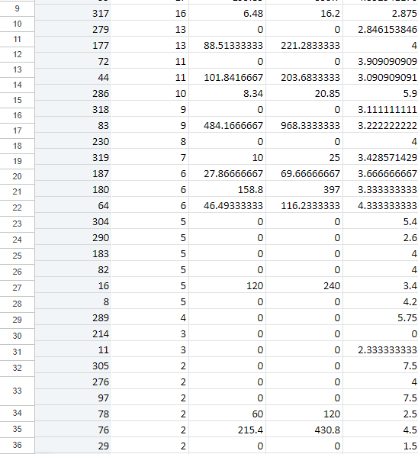

Agents with low performance are shown at the bottom area of the table, signifying either low calls handled or low handling efficiency.

Inferences from the Data:

These agents may be struggling with workload management, or possibly skill gaps, or efficiency problems.

Low call-handling efficiency may involve lengthy resolutions, which are, therefore inviting low customer satisfaction.

Action Plan:

Share workload:

Varies the number of calls by "utilizing customer needs to assign customers to appropriate agents".

Intervention for Low-Performing Agents Targeted

Educate them further on how to improve their communication and problem-solving skill and technical capabilities. Let them have less complex or interaction initially to regain their morale and performance.

Monitor Performance: It must be monitored over time to ensure improvements in handling efficiency and performance. By focusing on balancing workloads while targeting support, the team will optimize the performance of agents by ensuring that the needs of customers are well met.

**Q7.**How should the call center balance the workload among agents to ensure optimal performance and avoid burnout?

Mention your approach and spreadsheet function for the answer?

**Answer:**



* The table below the dashboard presents the volume of queries (calls and chat requests) answered by the gurus. What is most important to note here is that the volume is unevenly distributed across the gurus. For instance, some have received higher volumes than required, while others have received a very little volume; hence it drags the agents to levels of overburdening, otherwise called over-exhaustion, with resultant decreased productivity and eventual burnout or turnover.
* Action Plan:
* Analyze peak periods from historical data.
* Analyzing the historical calling and query logs, predict peak time.
* Action: Schedule agents accordingly to ensure optimal coverage during high-demand hours, minimizing stress during busy times.
* Implement shift work:
* Implement rotation of shifts so that agents do not work continuously in the stressful periods.
* Action: This will ensure that workload is distributed evenly among the members, free from burnout, and kept at a high morale level.
* Skill-based Routing:
* Implement a skill-based routing system, which will route calls based on the abilities of the agents.
* Action: Complex or high-priority issues are dealt with by the most experienced agents; simpler easy-to-answer questions are handled by less experienced/newer agents. More efficient, better service quality is obtained.
* Give mental health support
* Mental health services and support tools should be offered for managing stress levels and preventing burnout in agents. Action: Create an environment in which agents are supported in dealing with work pressures, fostering general well-being and better performance.
* Real-Time Performance Monitoring: Use real-time monitoring tools to track call handling times, queue lengths, and agent workloads. Action: This allows managers to step in and redistribute calls if any agent is receiving more calls than others, ensuring balanced workloads and avoiding overburdening any single agent. Expected Result: All these imbalances of workload, skill-based routing, rotation of shifts, and advocacy for the well-being of agents contribute to more efficient operations of a call center along with increased satisfaction among agents and reduced risks of burnout or turnover.

**Q8.**What new technologies or tools could be implemented to enhance call center operations and customer service?

**Answer: With advanced technologies and tools helping to streamline processes proactively boost productivity and customer satisfaction, the operations of a call center and all its customer interactions would definitely be improved. Among the key ones include:**

**1. Artificial Intelligence (AI) and Deep Learning**

**AI-Powered Chatbots:**

**AI-driven chatbots, enhanced with deep learning, can handle more complex customer queries, provide highly accurate, and context-aware responses. This can also help bring down the calls an agent needs to handle as chatbots can resolve issues quite efficiently on their own.**

**Tools to Consider:**

**For example, Google Dialogflow, Microsoft Azure Bot Services, IBM Watson Assistant, and others.**

**2. Robotic Process Automation (RPA)**

**Automation of Repetitive Tasks:**

**RPA can automatically perform such mundane jobs such as data entry, customer database updation information, and processing orders. This helps agents have extra time from less complex clerical work and dedicate more time on individual complex customer interactions.**

**Leading RPA Tools:**

**Other notable platforms are UiPath, Automation Anywhere, and Blue Prism.**

**3. Cloud-Based Call Centre Solutions**

**Flexibility and Cost Efficiencies: Scalable call center solutions through the cloud will provide businesses with very flexible platforms for remote working or adaptation to growing needs. Such cloud-based solutions will thus enable optimization of staffing and smoothness in operations even during disruptions occasioned by repercussions of such happenings.**

**Popular Cloud Solutions:**

**Examples include Amazon Connect, Twilio Flex, and RingCentral.**

**4. Integration with Customer Relationship Management (CRM)**

**Deep Customer Insight Further, on integration of the call center with a CRM system, the agents will be furnished with all history of customer interactions, preference, and even transaction details, hence, enabling them to personalize the delivery of their service according to the specific needs and history of each customer. Leading CRM Systems: Some of the examples include Salesforce, HubSpot CRM, and Zoho CRM, which allows easy integration with call centers to help in service delivery. Utilizing these advanced technologies, call centers can enhance effectiveness, operate more effectively, offer better customer services, and improve managerial practices.**.

**Q9.**What metrics should be included in the final dashboard to provide a comprehensive view of call center performance and guide investment decisions?

**Answer:**

* Key Metrics to Improve Business Performance and Point to Problems:
* Filters Used:
* Type of Consultation Filter

* Platform Filter of whether it was Website or App
* Metrics Reviewed with these Filters:
* Total Revenue Generated
* This metric shows the total revenue of a business from all activities. With the use of filters, this can then be broken down to show revenue either from specific consultation types, call or chat or both, and from various platforms like app or website. This is an important metric for evaluating the financial performance of a business.
* Total Active Gurus/Agents:
* This metric reflects the number of active agents or gurus available to handle customer interactions. Applying filters can use it to analyze exactly how many agents are working on which types of consultations through which platforms.
* Daily Active Users
* This will visualize the daily activity of users across all your platforms (be it an app or website). It is an important metric to understand how many users interact with the business on a daily basis and can track trends and changes in business performance.
* Daily Activity on Astrosage
* This chart would track the total daily activity across the platform, with calls as well as chats. Filters allow a more nuanced analysis that might visualize trends and shed light on areas of the business.
* Activity vs. Revenue:
* This comparison presents the relationship between user activity (calls, chats) and the revenue generated. It may be filtered to measure income by consultation preference, thus looking into which kinds of activities are most contributing to revenue.
* First-Time vs. Returning Users:
* This graph forms the basis of customer retention since it shows the percentage of repeat users, which is critical because a business cannot survive on new users alone. Analysis of repeat customers can demonstrate patterns to enhance strategies related to customer loyalty and retention.
* Overview of Platform Activity:
* This metric shows the user activity distribution by the type of consultations: for example, chat or call. The most popular preference for a consultation could be determined to possibly indicate areas that may need more marketing or service improvements.
* Average Rating Distribution
* This is one of the most important metrics for customer satisfaction. It can answer how customers value their experience with the business, giving a clear signal about service quality. The study of this data will provide guidance in different necessary improvements to enhance experience and satisfaction.
* These metrics, if tracked and analyzed effectively, provide an overall view of the business's performance and highlight the areas for improvement and optimization.

**Q10.How would you allocate a 1 crore rupee investment to optimize operational efficiency, enhance customer satisfaction, and boost profitability, and what analysis-based recommendations would you offer to support this?**

**[you have to give bullet pointers in order to answer this question]**

**Answer:**

Technology Up-gradation of (Rs. 35 Lakhs)

What Should Be Done Invest money into the best call distribution systems, AI chatbots, and CRM tools.

It Matters Why:

The more the number of customers calling in makes the scenario slightly chaotic. Upgrading the technology will ensure calls are routed efficiently and balance the workload across agents when it comes to the handling of peak times. Presence of Chatbots will deal with simple inquiries freeing up agents for tougher cases. Also, with AI in our CRM, we will most definitely be in a position to give customers a more personalized experience which can only serve us well in the long run.

What It Will Achieve

Efficiency: More timely responses and fewer agent-related stresses.

Revenues: The agents would be able to have more calls and chats once things get going, thus eventually sales.

Rs. 20 Lakhs Training Programs

What We Should Do: Run some targeted training to boost agent skills, especially in communications, problem-solving, and product knowledge.

Why It Matters:

While chats are great for engagement, they never seem to result in conversion. We have to improve the agents' chances of converting such conversations into something more revenue-generating. Training will enable them to make better use of the system to answer complex queries and reduce their resolution times due to happy customers.

What It Will Deliver:

More positive interactions with customers must result in a better rating and more repeat business.

Revenue: More skilled agents can upsell and cross-sell, maximizing the potential value of each engagement.

Additional agents (Rs. 30 Lakhs)

What We Should Do: Hire more agents to ensure that wait times are always short and the existing agents do not get burnt out.

Why It Matters:

As it stands today, agents become stretched out during peak times; this leads to a longer wait time and dissatisfied customers. When new members are hired, the workload will be spread, and no person will have to stand in an interminable line.

What It Will Accomplish:

Efficiency: The situation would have greater flow in general with more agents as wait times would be reduced.

Customer Satisfaction: The faster the service, the better it is. Customers will love it. Customer Retention & Marketing (Rs. 15 Lakhs)

What we have to do is reserve some of those dollars for loyalty programs and just marketing to get them coming back.

Why It Matters: We all know it’s easier to keep a customer than to find a new one. Loyalty programs based on customer feedback will help retain our current customer base and make them feel valued. Plus, we’ll use this money to run some marketing campaigns to keep attracting new customers while keeping the old ones happy. What It Will Accomplish Customer Loyalty: Specific offers and acting on feedbacks ensure that customers are satisfied and would come back for more. Revenue: By keeping customers around longer, we’ll have a more stable revenue stream and spend less on trying to attract new business. In the long run, each change might seem minimal, but it will help things smooth out, satisfy customers more often, and therefore increase the business's revenues. It is all about making the operation more efficient and keeping things flowing in the right direction.